Photographs of Cluster Bombs and Cluster Bomb victims in Syria
Cluster Bombs
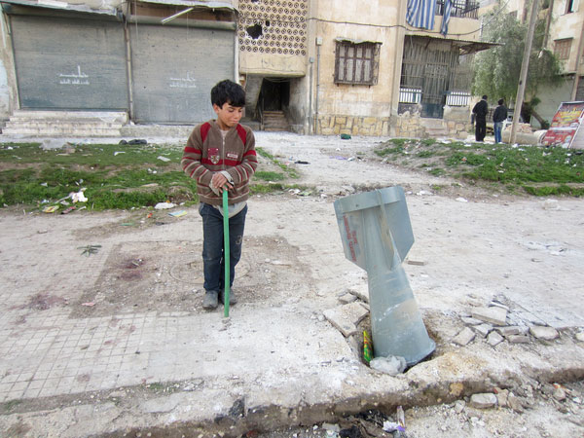 | Photo 1:  A child stands near an RBK cluster bomb tail fin in Aleppo, Syria, after the Syrian armed forces launched an airstrike on a residential area 1 March 2013.  The Syrian air force dropped nine Soviet-made RBK cluster bombs – each carrying up to 150 cluster submunitions – in the middle of a large housing estate.  © Amnesty International

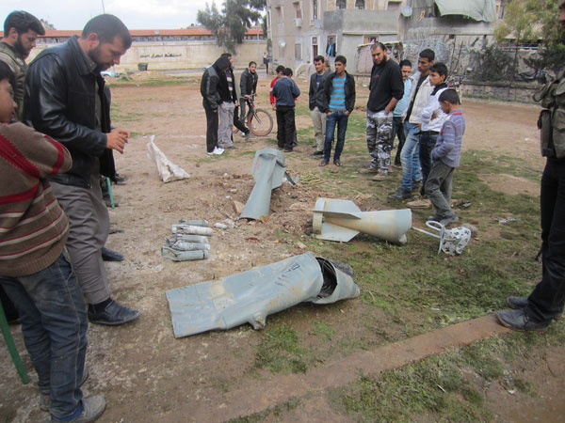 | Photo 2:  2 of 9 Russian made cluster bombs launched by Syrian government forces against a housing estate in Aleppo, Syria, on 1 March 2013, unexploded submunitions from a cluster bomb can be seen centre left.  © Amnesty International
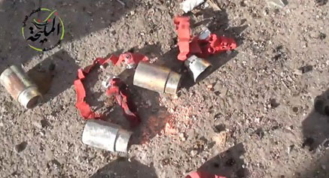 | Photo 3:  Screenshot from video, Maliha, Rural Damascus 4 April 2014: https://www.youtube.com/watch?v=rRGRVM4qaC8

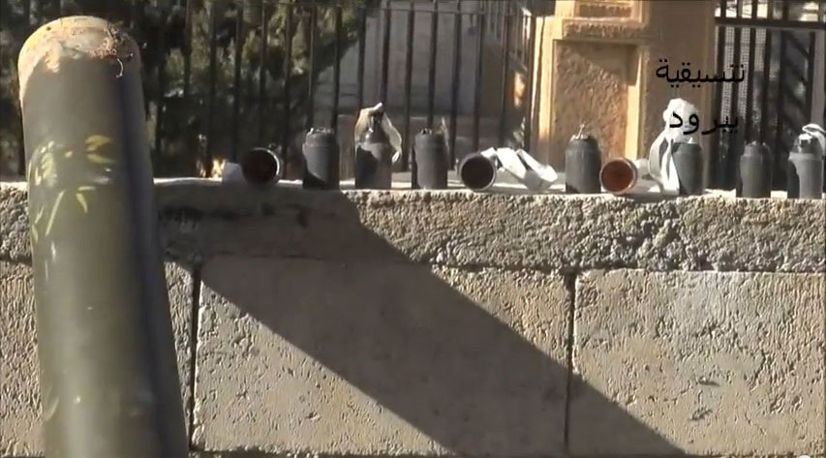 | Photo 4:  Screenshot from video, Yabroud, Rural Damascus February 7, 2014:  https://www.youtube.com/watch?v=WQU4QAwzbXw

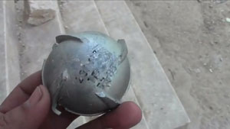 | Photo 5:  A Soviet-era ShOAB 0.5 submunition, not previously known to have been used in Syria, as seen in a YouTube video uploaded by local activists in Hesih or Hish in Idlib governorate on March 10, 2013.  © 2013 Private (Courtesy of Human Rights Watch)
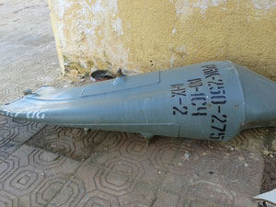 | Photo 6:  Remnants of a RBK-250/275 AO-1SCh cluster bomb in Deir Jamal from a strike on February 28, 2013.  © 2013 Human Rights Watch

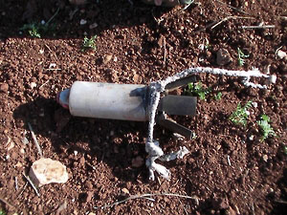 | Photo 7:  An unexploded 9N235 antipersonnel fragmentation submunition found in Keferzita in Syria. Each submunition contains 395 pre-formed fragments, some the mass of 9mm pistol bullets.  © 2014 Private (Courtesy of Human Rights Watch)

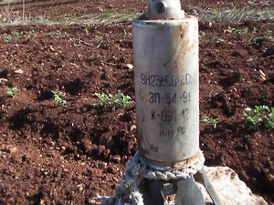 | Photo 8:  An unexploded 9N235 antipersonnel fragmentation submunition found in Keferzita in Syria. Each submunition contains 395 pre-formed fragments, some the mass of 9mm pistol bullets.  © 2014 Private (Courtesy of Human Rights Watch)
Cluster Bomb Victims
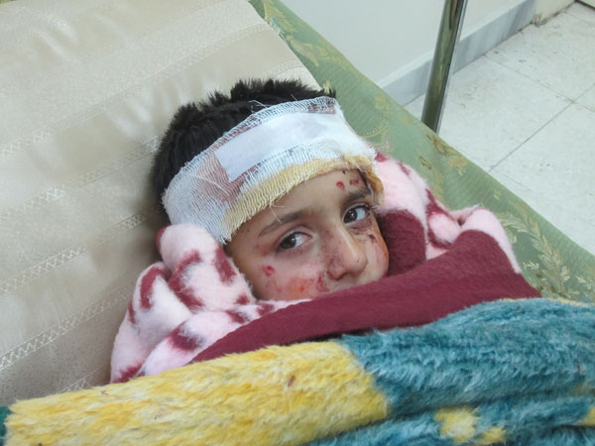 | Photo 9:  A child, Mustafa Ali, aged 6, in a field hospital in Aleppo, Syria after sustaining injuries in a cluster bomb attack by the Syrian armed forces on a residential area on 1 March 2013.  The Syrian air force dropped nine Soviet-made RBK cluster bombs – each carrying up to 150 cluster submunitions – in the middle of a large housing estate.  © Amnesty International

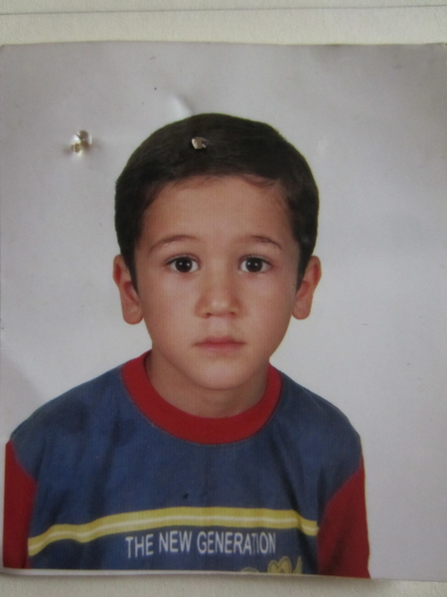 | Photo 10:  Abderraman Assuus, 10, killed by a cluster bomb in Salqeen on 18 Jan 2013.  © Amnesty International
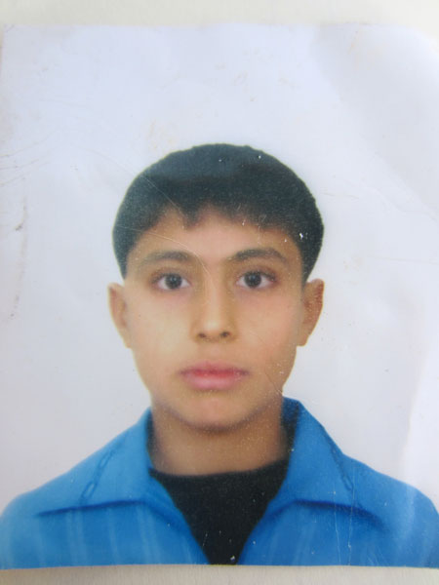 | Photo 11:  Musa Ramadhan Hassun, 16, killed when he picked up an unexploded cluster bomb dropped by Syrian government forces in Darkush, Syria, on 20 February 2013.  © Amnesty International

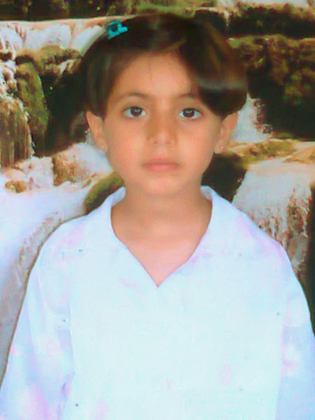 | Photo 12:  Nour al-Keis, 13, who was killed by a cluster bomb dropped by Syrian government forces in al-Najiya, Syria, in January 2013.  © Amnesty International
Please contact media@icblcmc.org to request a high resolution version of images, where available.

