Recorded Instances of Use and Testimonies of Cluster Bombs Attacks in Syria
Below are just a few of the many recorded instances of cluster bomb attacks in Syria over the last two years, since these banned weapons were first used in the conflict in July 2012.
Cluster munitions can be fired by artillery and rocket systems or dropped by aircraft, and typically explode in the air and send dozens, even hundreds, of small submunitions, or bomblets, over an area the size of a football field. Submunitions often fail to explode on initial impact, leaving duds that act like landmines.
Cluster munitions have been banned because of their widespread indiscriminate effect at the time of use, and the long-lasting danger they pose to civilians. When cluster munitions are used in civilian areas, civilian casualties and damage to civilian infrastructure are very difficult to avoid. Therefore, even for those countries that have not joined the ban convention, when used in populated areas, cluster munitions should be presumed indiscriminate in violation of international law.
The following are extracts from the testimonies collected by Cluster Munition Coalition (CMC) member organisation’s Human Rights Watch and Amnesty International – full testimonies available below.
“The second rocket exploded halfway through in the air and released bomblets that injured people including women and children and killed one internally displaced person from nearby Mourik village. The only infrastructure damage caused was from the shrapnel. I remember seeing at least 10 injured but I was told that it was much more.”
Keferzita, Syria, 12-13 February 2014
“Suddenly the jet came and dropped its bombs. The bombs fell from above, one after another, small bombs spread out in the sky. They were exploding everywhere, like a volcano erupting, on and on. Shrapnel hit me in my behind and back. I was taken to the hospital which was full of wounded people, many in critical condition.” Sheik Sa`eed Neighborhood, Aleppo City, Syria, 3 April 2013
“There were so many injured, they had horrible cuts and pieces of flesh missing. Little children were screaming in so much pain; it was heart breaking, and the medics in the field hospital didn’t know who to attend to first.”
Southern district of Sarmin, a small town in the Idlib governorate, Syria, 7 March 2013
“I heard people screaming. I ran toward them and found out that one of the streets where the bomblets dispersed had people in it at the time. When I reached the house, I saw heavily wounded children inside. The children had been inside the house when the bomblets entered the walls and exploded. After helping out the injured we found three people killed in one of the nearby houses. They were from the same family. The bomblet exploded next to them, we saw remnants. I was told that a fourth man was also found killed on the street. I think he was walking at the time.”
Talbiseh, Syria, 2 March 2013
“Inas, two years; Heba, 8; Rama, 5; Nizar, 6; Taha, 11 months; Mohamed, 18 months. They were all killed; why? Why bomb children?”
Scores of unexploded PTAB-2.5M sub-munitions (bomblets) contained in the cluster bombs were littering the pavements, alleys and gardens between the buildings and the rooftops. Some of the lethal bomblets had penetrated through the walls of the buildings, exploding inside people’s homes, and in several places the buildings’ walls were peppered with shrapnel holes.
On the pavements and in the alleys between the buildings there were pools of blood and pieces of human flesh of the residents who were killed and injured in the attack. Some residents were fleeing the area, terrified of further strikes.
“I was sitting outside my home with my friends; the little ones were playing around us. There were explosions; the children were screaming and then I don’t remember anything.”
Masaken Hanano district of Aleppo, Syria, 1 March 2013
“One of the bombs went through the roof and into Fatima’s home right above her bed. We tried to save her but the bomb had caused a huge wound by her waist and abdomen and she died almost immediately, as we were evacuating her from her home.”
Al-Najiya, a small village near the town of Jisral-Shughour, Syria, 9 February 2013
“Neighbours rescued him and brought him upstairs but he was already dead; he had gushing wounds to the head”. The strikes took place just after Friday prayer, with cluster bomblets exploding all along a main street lined with shops. Amnesty International counted more than 20 locations where cluster bomblets exploded and interviewed a dozen of people injured in the attack, most of them children. A fruit seller who was also injured in the strike told Amnesty International: “My neighbour Saad Rashid Aktaa and I were coming back from Friday prayers and we had almost arrived at my fruit stall when the explosion happened. Sa’ad was killed. He left behind five children who are now orphans. I was injured by shrapnel in the legs”.
Salqeen, a town in the west of the Idlib governorate, Syria, 18 January 2013
“I was coming back home with the children, we had been visiting our relatives here in the village, just a few streets away. It was about 1.30 pm. We were in the centre of the village when we heard a plane circling above, then it bombed but not immediately above us, but the bombs came to us, in the little street between the houses. Everything was full of smoke, I could not see anything, I could not see my children. When I found Nour she was lying face down in a pool of blood”
Al-Najiya, a small village near the town of Jisral-Shughour, Syria, 15 January 2013
“The bomblets killed two men: one died instantly while he was in his car and the other one died an hour later when a bomblet exploded in his hands while he was trying to throw it far away from the yard of his house. His hand was amputated by the explosion. His name is Ala` Nasser Othman. The wounded [I saw] included seven children, five women and three men.”
Latamneh, Syria, 3 January 2013
A journalist who visited the site four days after the attack told Human Rights Watch that the 10 people who were killed at the processing facility were local farmers who had brought their olives there for pressing, and that he saw no signs of military activity or weapons at the site.
Abu Hilal, Idlib, Syria, 27 November 2012
“Around 2:50 p.m. a MIG 23 appeared in the sky. I was 100 meters away from the playground. I looked outside and saw the MIG hovering around and then release six cluster bombs as it flew away. I saw two breaking in half. Then I heard a series of small explosions. It sounded like fireworks but of course louder. Then I heard people screaming and running toward the playground. I followed them with the rest of the men who were with me. When I reached the playground I saw five children dead and many other wounded. The severely injured children were taken to nearby hospitals and the ones with lighter wounds to a field hospital.”
Cluster Bomb Attack on Deir al-`Assafeer near Damascus, Syria, 25 November 2012
One member of the local relief committee who was in the area during the attack spoke to Human Rights Watch; he said that he first thought that the jet was attacking them with its machine-gun because he heard many small explosions.
Afterwards, however, they realized it was a cluster bomb attack because they found eight bomblets that had failed to explode because they fell on soft ground.
Souran, Aleppo, Syria, 30 October 2012
Hamza, a local resident and activist, told Human Rights Watch that the first cluster bomb attack on this village occurred on October 9, when a helicopter dropped a cluster bomb near the house of Umm Nazir, a 60-year-old woman, injuring her and her son.
“Hamza” sent Human Rights Watch two videos showing an elderly woman, whom he identified as Umm Nazir, lying in a makeshift hospital with both her legs amputated.
Eastern al-Buwayda, Homs, Syria, 9-18 October 2012
FULL TESTIMONIES

Keferzita, Syria, 12-13 February 2014
The local activist from Hama, who was present when four rockets hit the town on February 12 and 13, gave an account of the attacks to Human Rights Watch. He said that on the late afternoon of February 12:
“A rocket fell on the eastern part of Keferzita on a neighborhood called al-Makassem al-Hatef. There is a small square and the rocket fell there. The rocket released small bomblets when it exploded in the air. I did not see any helicopter or warplane at the time of the attack or before. One of the rockets did not explode, and military specialists dismantled the rockets and they found dozens of bomblets. They removed the fuze from every bomblet.”
“The second rocket exploded halfway through in the air and released bomblets that injured people including women and children and killed one internally displaced person from nearby Mourik village. The only infrastructure damage caused was from the shrapnel. I remember seeing at least 10 injured but I was told that it was much more. I only saw injuries from shrapnel but I didn’t see any amputations.”
The local activist told Human Rights Watch that he believed the rockets were launched from Hama airport just under 30 kilometers south of Keferzita, which is controlled by the Syrian government: “On February 12, in the afternoon around 4 maybe, I received a phone call from a [opposition] military source that two rockets were launched from Hama military airport. We all tried to alert the residents but not everyone was able to hide in time.”
According to its manufacturer, the BM-30 Smerch can launch 9M55K rockets from a minimum range of 20 kilometers to a maximum range of 70 kilometers.
The local activist said that the next day:
“Two rockets fell on the northern area [of the village] next to al-Ma`sara road, injuring several people. There were no deaths. I saw a 65-year-old man injured by fragments in his shoulder and his son’s wife injured in the leg. Both rockets exploded but also caused limited damage to infrastructure. The rockets were also launched from Hama airport. There were no airplanes flying before or after the attack. The injured were taken to the field hospital.”
The local activist said at least 20 unexploded submunitions were collected after the rocket attacks on February 12 and 13.
A doctor in Hama told Human Rights Watch that he had also witnessed the rocket attacks on Keferzita. He said the attacks killed two civilians – a child named Abdulrahman Rami Almahmood, 3 or 4 years old, and a man named Mahmood Talal Aldaly, approximately 25 years old – and wounded 10 more civilians.
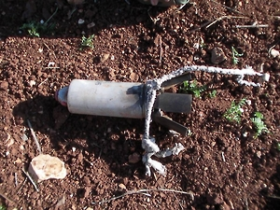 | 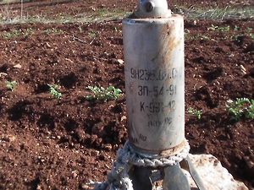
An unexploded 9N235 antipersonnel fragmentation submunition found in Keferzita in Syria. Each submunition contains 395 pre-formed fragments, some the mass of 9mm pistol bullets. © 2014 Private | An unexploded 9N235 antipersonnel fragmentation submunition found in Keferzita in Syria. Each submunition contains 395 pre-formed fragments, some the mass of 9mm pistol bullets. © 2014 Private

(Source: Human Rights Watch)

Sheik Sa`eed Neighborhood, Aleppo City, Syria, 3 April 2013
Just before noon on April 3, a jet dropped six cluster bombs on the Sheik Sa`eed neighborhood in Aleppo city, killing 11 civilians, including at least 7 children, and injuring many more.
“Mahmoud,” a local resident who was sitting on the roof with several members of his family at the time of the attack, told Human Rights Watch on April 9:
“Suddenly the jet came and dropped its bombs. The bombs fell from above, one after another, small bombs spread out in the sky. They were exploding everywhere, like a volcano erupting, on and on. Shrapnel hit me in my behind and back. I was taken to the hospital which was full of wounded people, many in critical condition.”
Mahmoud and his mother showed Human Rights Watch shrapnel from the attack and said that a local armed group had collected six cluster bomb canisters from the attack. Human Rights Watch was not able to inspect the remnants of the bombs.
Local residents said that a building used by an armed opposition group about 100 meters away could have been the target. The attack site is located on the southern side of city, not far from ongoing fighting between government and opposition forces. The building used by the armed opposition group appears to have been a legitimate military target, but the use of cluster bombs was unlawful because of their indiscriminate effect in a populated area.
Witnesses told Human Rights Watch that there were no opposition fighters among the casualties, and that opposition fighters were not in the area at the time of the attack. This information is consistent with the VDC casualty database, which lists all casualties as civilian.
(Source: Human Rights Watch)

Southern district of Sarmin, a small town in the Idlib governorate, Syria, 7 March 2013
On the morning of 7 March a double cluster bomb strike on a southern district of Sarmin, a small town in the Idlib governorate, killed a 10-year-old girl, Amani al-Sheikh Ahmad, and a 25-year-old mother of two, Rania Kashtu, and injured more than 10 civilians, including several children. Residents told Amnesty International that the double air strikes happened at about 10 am.
A resident told Amnesty International: “There were so many injured, they had horrible cuts and pieces of flesh missing. Little children were screaming in so much pain; it was heart breaking, and the medics in the field hospital didn’t know who to attend to first.”
Footage of the aftermath of the bombing shows a number of unexploded AO-1 SCH fragmentation bomblets, 8 the other type of cluster sub-munitions contained in the RBK bombs which are frequently dropped by Syrian aircraft.
(Source: Amnesty International)
Talbiseh, Syria, 2 March 2013
A cluster bomb attack on Talbiseh in Homs on March 2 killed 4 and wounded 26 civilians, including 6 women and 7 children.
On March 2, a local activist in Talbiseh recorded video footage (subsequently uploaded online by the Committee to Protect Civilians-Talbiseh) of a cluster bomb attack on his neighborhood in the northern suburbs. Human Rights Watch interviewed the activist to corroborate the video evidence. The video captures the cluster bomb strike as it happens, showing the munition break apart and scatter submunitions, including some that fail to explode and bounce toward the camera. The activist described the attack to Human Rights Watch:
“I was walking around in Talbiseh. … My camera is always on. I never turn it off because you never know when you will use it. When I reached the square in the center of Talbiseh I heard the sound of an explosion in the air and then explosions on the ground just in front of me. I heard another explosion, but the sound came from further away.”
“I heard people screaming. I ran toward them and found out that one of the streets where the bomblets dispersed had people in it at the time. When I reached the house, I saw heavily wounded children inside. The children had been inside the house when the bomblets entered the walls and exploded. After helping out the injured we found three people killed in one of the nearby houses. They were from the same family. The bomblet exploded next to them, we saw remnants. I was told that a fourth man was also found killed on the street. I think he was walking at the time.”
“We found several unexploded bomblets. I don’t remember the exact number. The bomblets from the two bombs dispersed over seven streets and the first three streets were the most damaged and were populated at the time. The bomblets created small holes on the ground and on walls of houses. The cluster bomb explosion that you see in the video caused several injuries and casualties. The second cluster bomb attack, 500 meters away from the first one, did not cause any civilian damage because it fell in an area with no residents.”
In total, the cluster bomb attack on March 2 killed at least four men, all civilians according to the activist, and wounded 26 people. The activist visited the local field hospital after the attack, where he said he counted the 26 wounded civilians, including 7 children and 6 women. He said that four men injured in the attack appeared to be in critical condition with internal bleeding caused by shrapnel. “The field hospital is not equipped so the medical team could not perform surgeries and at the same time we could not evacuate the wounded because of the siege imposed by the Syrian army,” the activist said.
The four men killed as a result of the cluster bomb attack were: Abdel Rahman al-Masri, Ahmad Swaiss, Selim Mohamad Miznazi, and Mohamed Abdel al-Kafi al-Mer`I.
From video footage uploaded online by the Network of Syrian Revolution News in Talbiseh, a group of Talbiseh activists, of remnants and description by the activist, Human Rights Watch has identified the remnants of a RBK cluster bomb canister.
Unexploded submunitions and other remnants left from the cluster bomb attack pose a deadly risk to those who handle them. The witness said: “An hour after the bomb canister hit the ground part of it exploded … but didn’t cause any injuries.”
The activist said that the Free Syrian Army troops were based one kilometer away from the site of the attack. “FSA brigades are only located around the town, which is seen as the frontline between them and the army,” he said. “They don’t have any vehicles inside the town and as you can see in the video all the people were civilians and the FSA was not present. Liwa` al Islam [an armed opposition group] is very active in Talbiseh. … Following the cluster bomb attack, tank shelling started.”
According to the activist, approximately one-third of Talbiseh residents had left the town after their homes were destroyed by shelling, but internally displaced residents from Homs had relocated to Talbiseh. “The regime knows that Talbiseh is a populated area,” he said. “The Syrian army now has surrounded us from all sides, making it harder to leave the town. We are stuck here.
(Source: Human Rights Watch)

Masaken Hanano district of Aleppo, Syria, 1 March 2013
“Inas, two years; Heba, 8; Rama, 5; Nizar, 6; Taha, 11 months; Mohamed, 18 months. They were all killed; why? Why bomb children?” As he spoke to Amnesty International, these children’s relative was still trying to find out about the fate of other members of his family, including four children, who had been injured and rushed off, some of them to hospitals across the border in Turkey.
A dozen other civilians were killed and scores more injured in this multiple cluster bomb attack on a densely populated housing estate in the Masaken Hanano district of Aleppo on 1 March 2013 at about 11.30 am. Among those killed were Mahmud al-‘Asal and his 16-year-old son Iyad; 10-year-old Noura Ibrahim; and 60-year-old Adnan Kamil. Medical workers at one of the field hospitals said that three of the bodies they had received were in shreds and had not yet been identified.
When an Amnesty International delegate visited the site, two hours after the attack, she found nine Russian-made RBK bombs – one only metres from the front door of one of the buildings; three in a small garden between the buildings; one on the roof of a building; two in a small empty space between buildings; one in the middle of an alley; and one in another garden. Scores of unexploded PTAB-2.5M sub-munitions (bomblets) contained in the cluster bombs were littering the pavements, alleys and gardens between the buildings and the rooftops. Some of the lethal bomblets had penetrated through the walls of the buildings, exploding inside people’s homes, and in several places the buildings’ walls were peppered with shrapnel holes.
On the pavements and in the alleys between the buildings there were pools of blood and pieces of human flesh of the residents who were killed and injured in the attack. Some residents were fleeing the area, terrified of further strikes.
A 10-year-old girl showed Amnesty International the spot where her three-year-old brother, Ibrahim, was standing, just outside the family’s ground floor apartment, when he was struck on the head by shrapnel from one of the scores of cluster sub-munitions (bomblets) which exploded all over the housing estate.
In an apartment in one of the buildings 18-year-old Mahmoud, lay on the floor with shrapnel lacerations to his face, legs and arms. Blood was seeping through the bandages Shaking and visibly in shock, he said: “I was sitting outside my home with my friends; the little ones were playing around us. There were explosions; the children were screaming and then I don’t remember anything.” Relatives said the youth was found in pool of blood. He was taken to a field hospital, where he was given basic treatment and released. Field hospitals have few human or material resources, and have to release patients as quickly as possible because they fear attacks – hospitals have been bombed in the past year.
Amnesty International recorded the names of 60 people, more than half of them children, who were being treated in field hospitals in Aleppo city. They included seven-year-old Abdo al-Dik, who suffered deep lacerations to his abdomen and legs. His three-year-old brother Nizar was killed in the attack and another brother, aged six, was still missing several hours after the strike. Six-year-old Mustafa Ali, who had sustained shrapnel injuries to the head, neck and shoulders, did not know what had happened to the relatives he was visiting when the bombs struck. Noura, a 20-year-old woman, sustained multiple fractures to her left leg when a cluster sub-munitions exploded inside her ground-floor apartment.
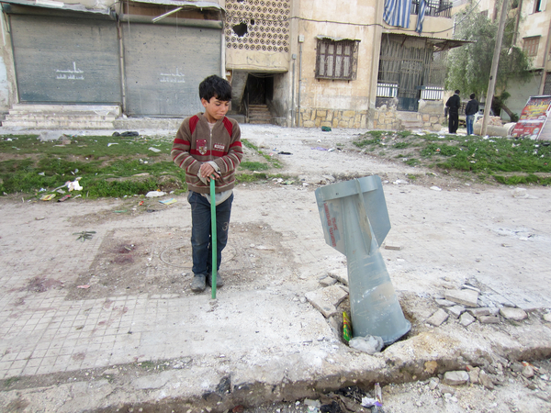 | 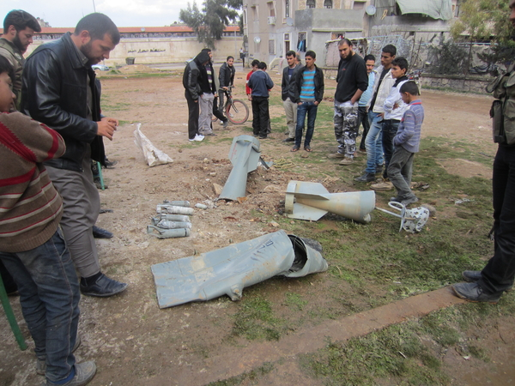
A child stands near an RBK cluster bomb tail fin in Aleppo, Syria, after the Syrian armed forces launched an airstrike on a residential area 1 March 2013. The Syrian air force dropped nine Soviet-made RBK cluster bombs – each carrying up to 150 cluster submunitions – in the middle of a large housing estate.  © Amnesty International | 2 of 9 Russian made cluster bombs launched by Syrian government forces against a housing estate in Aleppo, Syria, on 1 March 2013, unexploded submunitions from a cluster bomb can be seen centre left.  © Amnesty International
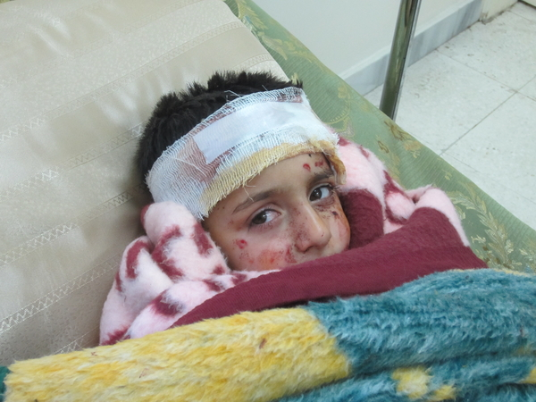
A child, Mustafa Ali, aged 6, in a field hospital in Aleppo, Syria after sustaining injuries in a cluster bomb attack by the Syrian armed forces on a residential area on 1 March 2013.
The Syrian air force dropped nine Soviet-made RBK cluster bombs – each carrying up to 150 cluster submunitions – in the middle of a large housing estate.
© Amnesty International

(Source: Amnesty International)

Al-Najiya, a small village near the town of Jisral-Shughour, Syria, 9 February 2013
An elderly widow, Fatima Bakkour, was killed in her bed when a cluster bomblet went through the roof and exploded into her home in the afternoon of 9 February 2013. One of the volunteers who tried to rescue the woman told Amnesty International: “One of the bombs went through the roof and into Fatima’s home right above her bed. We tried to save her but the bomb had caused a huge wound by her waist and abdomen and she died almost immediately, as we were evacuating her from her home.”
(Source: Amnesty International)
Salqeen, a town in the west of the Idlib governorate, Syria, 18 January 2013
In Salqeen, a town in the west of the Idlib governorate, 18 people were killed and dozens more injured, most of them children, on 18 January 2013 in a cluster bomb attack in the centre of the town. Among the victims were two 10-year-old school children, Rawan Yaser Darukh and Abd al-Rahman Aasous. Rawan was killed and her siblings and cousins were injured when a cluster bomblet exploded as they were playing outside the family’s grocery store. Abd al-Rahman’s parents told Amnesty International that the boy had been playing in the street downstairs from their apartment when the explosions happened: “Neighbours rescued him and brought him upstairs but he was already dead; he had gushing wounds to the head”. The strikes took place just after Friday prayer, with cluster bomblets exploding all along a main street lined with shops. Amnesty International counted more than 20 locations where cluster bomblets exploded and interviewed a dozen of people injured in the attack, most of them children. A fruit seller who was also injured in the strike told Amnesty International: “My neighbour Saad Rashid Aktaa and I were coming back from Friday prayers and we had almost arrived at my fruit stall when the explosion happened. Sa’ad was killed. He left behind five children who are now orphans. I was injured by shrapnel in the legs”.
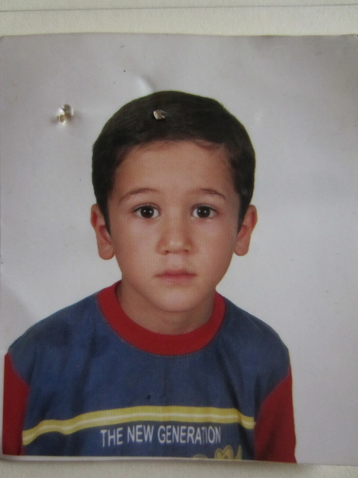
Abderraman Assuus, 10, killed by a cluster bomb in Salqeen on 18 Jan 2013.
© Amnesty International
(Source: Amnesty International)
Al-Najiya, a small village near the town of Jisral-Shughour, Syria, 15 January 2013
In al-Najiya, a small village near the town of Jisral-Shughour, several residents were killed and injured by cluster bombs in recent months. A 13-year-old girl, Nour Mustafa al-Keis, was killed and her three sisters, baby brother and mother were injured when cluster bombs rained on the village on 15 January 2013. Nour’s mother told Amnesty International: “I was coming back home with the children, we had been visiting our relatives here in the village, just a few streets away. It was about 1.30 pm. We were in the centre of the village when we heard a plane circling above, then it bombed but not immediately above us, but the bombs came to us, in the little street between the houses. Everything was full of smoke, I could not see anything, I could not see my children. When I found Nour she was lying face down in a pool of blood”. Nour’s mother and siblings are still suffering from multiple shrapnel injuries to their faces and bodies, and some 10 other villagers were also injured in the attack, some seriously.
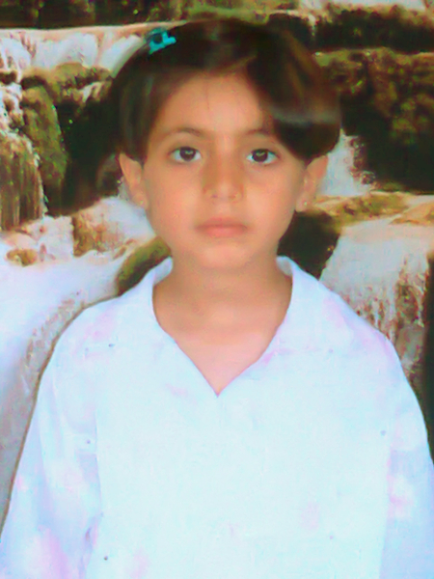
Nour al-Keis, 13, who was killed by a cluster bomb dropped by Syrian government forces in al-Najiya, Syria, in January 2013.
© Amnesty International
(Source: Amnesty International)
Latamneh, Syria, 3 January 2013
A resident of Latamneh described to Human Rights Watch the cluster munition strike on January 3 on his town, located northwest of Hama city:
“Around 4 p.m., four rockets hit in Latamneh. It was raining a lot that day. It stopped and this was when we heard a very loud sound and then a big explosion. After that we heard a series of smaller explosions. The four rockets fell in different areas: three fell in the fields and the other one on the street between residential buildings.”
“One that exploded on the street next to a residential building caused a lot of damage. It killed two men and wounded 15 [including] women and children. Some were walking on the street at the time and others were in their house. Salah Mohammed Husain al Kharouf (around 45 years old) … was in his car driving when the bomblets exploded. He died instantly.”
The resident told Human Rights Watch that al Kharouf was not a combatant. The resident said and graphic video footage shows that a 30-year-old man named Ala` Othman Zain, also identified as a civilian, was killed after the strike when he picked up a submunition that exploded in his hands. Video footage apparently shot in a local medical facility on the day of the strike shows a dead man with his right hand blown off and wounded civilians receiving treatment, including a baby, a young girl, boys, women, and men. One video shows a severe fragmentation wound on the baby’s right arm. Local residents said the people who were severely wounded were taken to Turkey for treatment, where they remain.
The resident visited one of the attack sites and told Human Rights Watch that he saw “bomblets spread out around 200 meters” including 20 unexploded submunitions. He took video footage that shows the remnants of a rocket and 10 explosive submunitions and said, “We took [the rocket and unexploded submunitions] with us back home. After we finished filming them we placed them in a bag and threw them away in the fields. They all exploded. It was the safest way to destroy them.”
The resident said that the Syrian Army has not been in Latamneh, but that the Free Syrian Army has been present since mid-December. The resident said that the town has been attacked by Syrian government planes and helicopters, but that the attack on January 3 was different because, “This was the first time this kind of rocket is used on us.” He said that the rockets were not dropped from an airplane: “There was no airplane that day. It was very foggy even after the rain stopped. The rocket came from the direction of Hama airport, located 40 km away from our town.”
Another resident told Human Rights Watch that Free Syrian Army (FSA) fighters in Latamneh told him that FSA fighters near Hama airport had informed them that the rockets were launched from the vicinity of the airport on January 3.
Another local resident described the January 3 attack to Human Rights Watch:
“I heard a big explosion followed by smaller ones. It was still very cloudy but the rain stopped. After the explosions stopped I went to see what happened. The buildings that were hit were 200 meters away from the office. When I arrived I saw wounded people everywhere and small bombs covering the streets. The damage caused to the buildings was minimal. I saw a lot of unexploded bomblets. I don’t remember how many but more than 10.”
“The bomblets killed two men: one died instantly while he was in his car and the other one died an hour later when a bomblet exploded in his hands while he was trying to throw it far away from the yard of his house. His hand was amputated by the explosion. His name is Ala` Nasser Othman. The wounded [I saw] included seven children, five women and three men.”
The resident said there was no FSA vehicle, office, or gathering near or at the buildings hit in the attack. He said that at the time of the cluster munition attack, clashes between the FSA and the Syrian army were taking place at the village of Bamourk, seven kilometers away.
Other videos uploaded to YouTube show remnants of the rocket and submunitions apparently used at Latamneh, including one video of a field pockmarked by small craters with several unexploded submunitions visible and another video showing unexploded submunitions in a residential area.
(Source: Human Rights Watch)

Abu Hilal, Idlib, Syria, 27 November 2012
On the morning of November 27, 2012, cluster munition air strikes at Abu Hilal, two kilometers west of the northern city of Idlib, killed at least 12 civilians and wounded at least 10 more according to Human Rights Watch phone interviews with two local residents and a journalist who visited the site four days after the attack. They said that the dead included two women and one child. In the first air strike, at least 10 civilians at an olive oil processing facility were killed and more than 10 were wounded when an aircraft dropped two cluster bombs, the residents said. A separate strike on a nearby olive grove killed two women working there. A journalist who visited the site four days after the attack told Human Rights Watch that the 10 people who were killed at the processing facility were local farmers who had brought their olives there for pressing, and that he saw no signs of military activity or weapons at the site.
Analysis by Human Rights Watch of video footage posted online by Syrian activists of the scene and on the date of the attack indicates that the Syrian Air Force used RBK-250 bombs containing PTAB-2.5M anti-armor bomblets in the attack. Human Rights Watch established the location of the air strike on the olive oil processing facility by matching video from the scene to satellite imagery. A local resident told Human Rights Watch that there was no activity by the FSA “near or around” the facility.
(Source: Human Rights Watch)

Cluster Bomb Attack on Deir al-`Assafeer near Damascus, Syria, 25 November 2012
Compelling evidence has emerged that an airstrike using cluster bombs on the town of Deir al-`Assafeer near Damascus killed at least 11 children and wounded others on November 25, 2012.
According to video footage and testimony from local residents, at least 11 children were killed in the strike on Saraya neighborhood in the eastern part of Deir al-`Assafeer. Two residents told Human Rights Watch that the cluster bomb strike occurred as a group of at least 20 local children were gathered in a field where they usually play.
One witness said:
“Around 2:50 p.m. a MIG 23 appeared in the sky. I was 100 meters away from the playground. I looked outside and saw the MIG hovering around and then release six cluster bombs as it flew away. I saw two breaking in half. Then I heard a series of small explosions. It sounded like fireworks but of course louder. Then I heard people screaming and running toward the playground. I followed them with the rest of the men who were with me. When I reached the playground I saw five children dead and many other wounded. The severely injured children were taken to nearby hospitals and the ones with lighter wounds to a field hospital.”
A Human Rights Watch analysis of videos posted online by Syrian activists of the scene of the attack indicates that at least three RBK-250/275 AO-1SCh cluster bombs were used in the strike. Each RBK-250/275 AO-1SCh cluster bomb contains 150 AO-1SCh antipersonnel fragmentation bomblets and creates a destructive footprint of 4,800 square meters (52,000 square feet), the equivalent of a United States football field, according to a standard international air-launched reference guide. Markings on the cluster bomb remnants indicate they were manufactured in the Soviet Union in the 1970s. There is no information available on how or when Syria acquired them.
Video footage posted by Syrian activists of the immediate aftermath of the attack shows children and adults lying severely wounded on the ground, with injuries consistent with those caused by cluster bombs.
Cluster bomb remnants and local testimony indicate that one bomb landed in the field where the witnesses said the children were playing, a second bomb landed on a house less than 50 meters away, and the third bomb landed in farmland approximately 150 meters from the field.
One video shows unexploded bomblets found in the field where the witnesses said the children were playing. On the video, a resident who lives next to the field says that at least six children died in the field from the attack: Shahd al-Lahham al-Omar, 4 years old, Mamdouh Shehab, 11, Mohamad al-Shafouni, 11, Roba Youssef al-Ali, 13, and two other unnamed children.
According to local residents, a second cluster bomb remnant was found less than 50 meters away from the field and killed four children in a house: Mohamad Bassel al-Lahham, 5, Eman al-Lahham, 12, `Adnan al-Hussein, 7, and `Anoud Mohamad, 12. An old man was also severely wounded.
A third cluster bomb remnant was found in the farmland 150 meters from the field where the children were playing. The cluster bomb killed Zeinab Othman, 12, and one of her parents. The family was working in the farmland at the time, a resident said. The cluster bomb attack also killed and maimed cattle grazing in the area.
The witnesses said that there is no base for the rebel Free Syria Army (FSA) near or around the area. “There is no FSA equipment, machinery or anything else around the fields or near the farmlands,” one resident told Human Rights Watch. Another said: “There were no FSA vehicles or machinery visible. FSA soldiers do not live in residential areas.” Human Rights Watch has not been able to confirm independently the presence or otherwise of any fighters but the large number of children playing outside at the time of the strike would be consistent with the absence of any fighting in the immediate area.
From the video footage, Human Rights Watch identified more than 50 unexploded AO-1SCh bomblet remnants. Unexploded bomblets pose a deadly risk to those who handle or approach them. There is an urgent need for risk education and support to emergency clearance efforts in Syria to tackle the unexploded ordnance created from the use of cluster munitions and other explosive weapons.
Two witnesses told Human Rights Watch that an MIG airplane flew over again that day and dropped approximately six cluster bombs on another neighborhood in the eastern part of Deir al-`Assafeer.
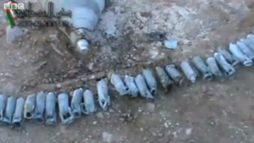
Video footage from Deir al-`Assafeer shows cluster bomb remnants including unexploded AO-1SCh bomblets that were collected by activists after they were dropped in an airstrike on November 25. The unexploded bomblets pose a deadly risk to those who handle or approach them.

(Source: Human Rights Watch)

Souran, Aleppo, Syria, 30 October 2012
Around 7:30 p.m. on October 30, a jet dropped at least one cluster bomb on the edge of Souran, injuring three civilians, according to local residents. One member of the local relief committee who was in the area during the attack spoke to Human Rights Watch; he said that he first thought that the jet was attacking them with its machine-gun because he heard many small explosions.
Afterwards, however, they realized it was a cluster bomb attack because they found eight bomblets that had failed to explode because they fell on soft ground.
Human Rights Watch examined the site of the attack and documented damage to buildings
and streets consistent with the use of cluster bombs. Photos and videos of the bomblets provided by local activists and reviewed by Human Rights Watch show eight PTAB-2.5M anti-armor bomblets.
(Source: Human Rights Watch)

Eastern al-Buwayda, Homs, Syria, 9-18 October 2012
Between October 9 and 18, four cluster bomb attacks on the village of Eastern al-Buwayda,
near Qusayr, in Homs governorate, wounded at least four people, according to local residents, including two of those wounded. Hamza, a local resident and activist, told Human Rights Watch that the first cluster bomb attack on this village occurred on October 9, when a helicopter dropped a cluster bomb near the house of Umm Nazir, a 60-year-old woman, injuring her and her son. A neighbor described the attack:
“It was around 3 p.m. when I heard one small explosion and then a series of explosions, but not very loud. The house didn’t shake when the bomb hit the street. Buildings around where the cluster bomb was dropped...only had small holes but they were not very deep. The cluster bomb hit a street with 10 buildings. The buildings are in habited, but most residents were not hurt. One woman called Umm Nazir was injured. Her house was 20 meters away from where we found the tail of the bomb. Her 30-year-old son was with her in the same house and was injured. He had injuries all over his body from shrapnel, but they were not deep or severe.”
“Hamza” sent Human Rights Watch two videos showing an elderly woman, whom he identified as Umm Nazir, lying in a makeshift hospital with both her legs amputated.
Hamza sent Human Rights Watch footage of remnants of the bomb that he says was used on October 9.
(Source: Human Rights Watch)

